“The world’s oceans are becoming a ‘toxic soup’ of industrial waste and plastic” Sir David Attenborough

Zero Waste Shopping
with Everything Usefill’s pop-up shop
Saturday 10th August 10 –12.30
St Francis Church Rooms,
Southam Street, Kineton

teas and coffees available
Talk at 10.00 am
10.30 – 12.30 – shop!
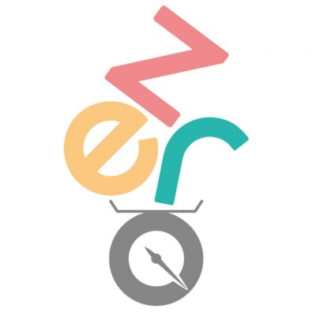
It works like this:
- Bring any clean, dry, empty container
- Choose your goods (from pasta & spices to cleaning products)
- Container contents are weighed
- Pay and enjoy without the plastic waste

